

Fig. 1 SETU logo

Software Development Year 4 Project

Planned and Unplanned Maintenance Application

Design Specification – First Draft

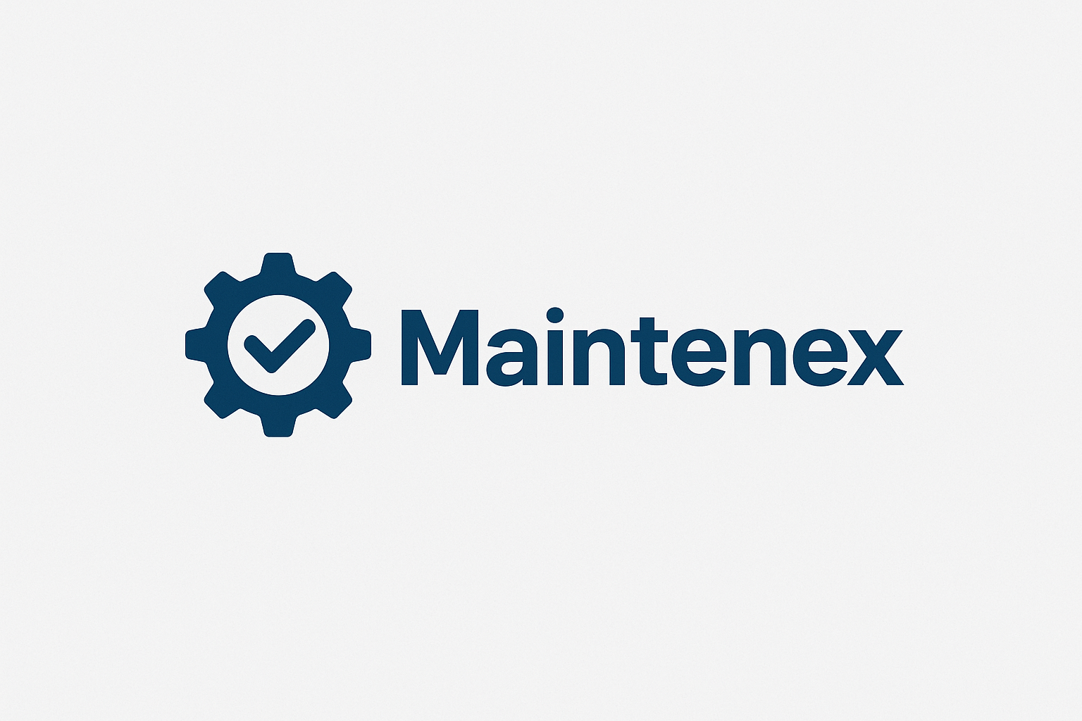

Fig. 2 Maintenex logo

Student: Nebojsa Kukic

Student No: C00283550

Date: 2025/2026

Supervisor: Tom Corocoran

Introduction

This design document outlines a detailed plan on how Maintenex will made created. Here we will see how it will fulfill its requirements by showing the design and technological choices used. The primary purposes of this application are the probability of failure on virtual machines using synthetically generated data on a virtual machine with the help of ML, along with the maintenance of other general machines. When it comes to the general machines technicians will have a tool to see previous services done, log work, see the current condition of machines along with being able to receive real-time alerts on the machine’s needs. The application will have an emphasis on created a easy to learn user interface which will be aesthetically pleasing.

Technologies

Much research has been exercised on what technologies will be used to create the Maintenex application. Below is an overview on what technologies were chosen to use for this application and their roles for this application to be built.

Python: serves as the main programming language of this application. It is powerful when it comes to the generation of synthetic data and machine learning techniques, thanks its powerful libraries, such as Pandas, NumPy, and Scikit-Learn. It’s the p
Flask: Will be used to create and structure a secure web application. It will drive the backend of the application, thus providing a powerful connection between the web interface and database.
React: will be used to create the front end of the application, this helping with created a UI which is both easy to use and aesthetically pleasing.
Simple Mail Transfer Protocol: Will be used to send automated email alerts to technicians and engineers when a machine requires planned and unplanned maintenance. For example, .
JSON: will be used to store the machine maintenance specification such as, service intervals and configuration settings. These JSON configuration files will be adjustable as some parts require difference service interval times. JSON is lightweight and easy to read and integrates very well with Python and Flask.
MySQL: will be used to store the necessary data. Here the machine information, maintenance logs, user accounts and scheduling data will be stored. It is useful in providing reliable and structured storage that can be accessed and analyzed efficiently.

Creation of Synthetic Data

The use of real data from machines is not available. The generation of synthetic data will be need. This is a complicated task to do as the data must be realistic and follow the engineering rules of how machines operate. With the help of my previous engineering supervisor and resources, the generation of realistic synthetic data will be created with the help of Python’s NumPy and Pandas following real-world engineering rules.
Here is an example of some of the data that was generated following these real-world engineering rules:

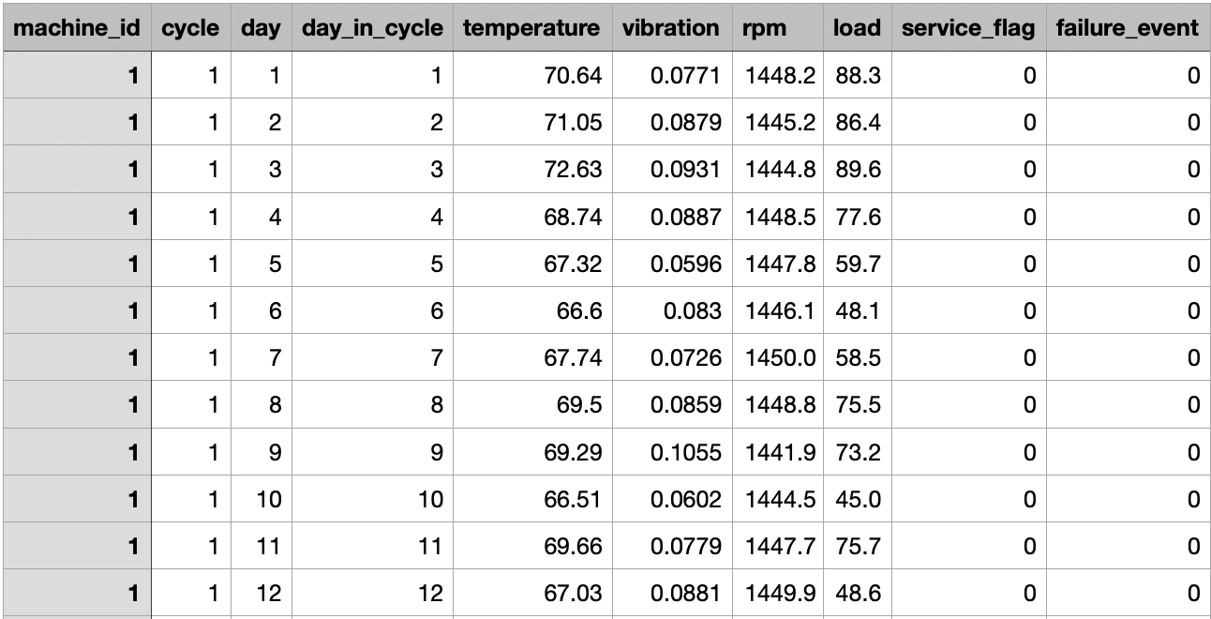

Background

My motivation for developing a Planned and Unplanned Maintenance Application rises from my previous work experience at Bausch & Lomb. A long leading giant in ocular health. They have a tremendous amount of machinery making and packaging contact lenses and these machines break down on a frequent basis. They use a similar system to track the scheduling of servicing and maintenance of these machines. My motivation comes from this system as in today’s world it is critical to have such applications to track, predict and schedule maintenance intervals for such machines.
I am driven to leverage my skills in AI and machine learning to create a solution that reduces the downtime of machinery, to predict failure of these machines and intelligent scheduling seamlessly into one application.

UI/UX
The creation of a great User Interface and User Experience is a complicated procedure. The UI this case must follow a simple design for technicians to be able to use it, along with the fact of being aesthetically pleasing to the eye.

Maintenex Login Page
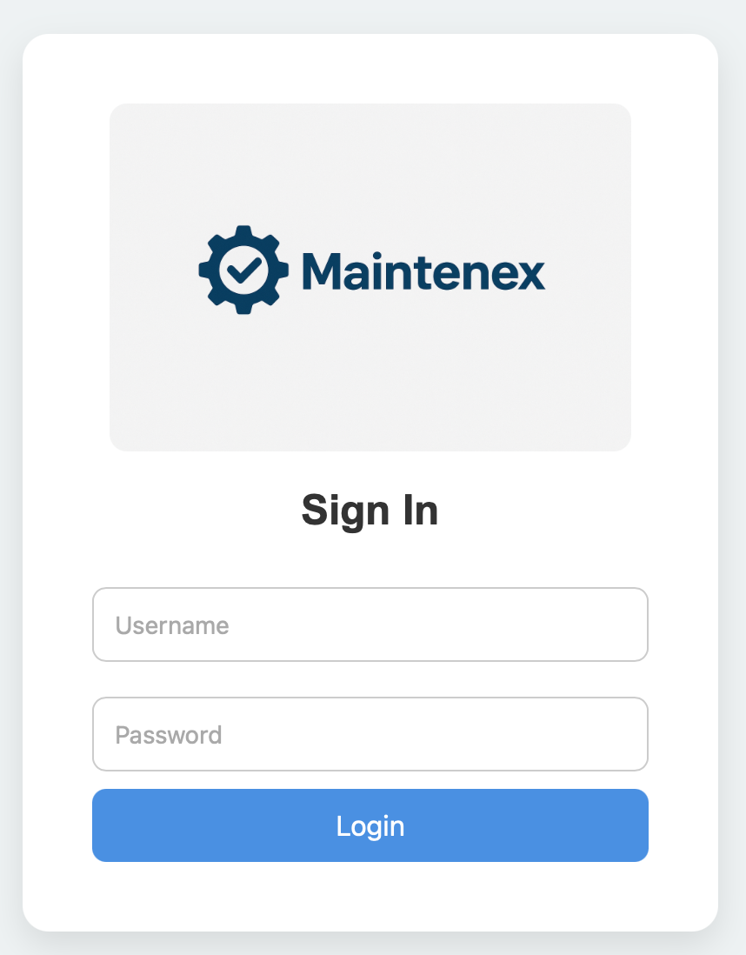

Nav Bar

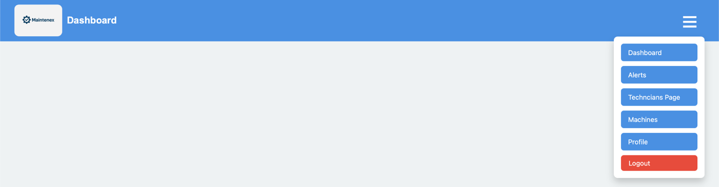

The difference between Machines

There will be two sections of the application when it comes to the machines. They will split on the virtual machine which show the predicting power of the ML on the virtual machine using the synthetically generated data, and the general machines in which technicians will have work to do, check previous services, schedule work, log work, along with real-time alerts notifying technicians on any work that must be carried out on any machines that are needing any servicing done. 